  Day of Prayer for survivors & victims of Abuse | Abstract  A Mass and Resource Pack including additional prayers, reflection, readings, Gospel text, hymns and atonement  DATE  20th FEBRUARY 2026

CONTENTS

MASS…………………………………………………….2

INTRODUCTION………………………………………9

PRAYERS………………………………………………..12

PRAYERS of INTERCESSION………………………14

REFLECTIONS…………….………………………..18

READINGS……………………………………………...23

RESPONSORIAL PSALMS………………………….25

GOSPEL TEXTS………………………………………..28

LITANIES…………………………………………………31

SYMBOL OF LIGHT & HOPE………………….…… 33

CONCLUDING PRAYERS……………………………36

MUSIC & HYMNS ……………………………………. 38

Introduction
In August 2018, Pope Francis wrote:

“It is always helpful to remember that “in salvation history, the Lord saved one people. We are never completely ourselves unless we belong to a people. That is why no one is saved alone, as an isolated individual. Rather, God draws us to himself, taking into account the complex fabric of interpersonal relationships present in the human community. God wanted to enter into the life and history of a people” (Gaudete et Exsultate, 6).

Consequently, the only way that we have to respond to this evil (of abuse) that has darkened so many lives is to experience it as a task regarding all of us as the People of God. This awareness of being part of a people and a shared history will enable us to acknowledge our past sins and mistakes with a penitential openness that can allow us to be renewed from within. Without the active participation of all the Church’s members, everything being done to uproot the culture of abuse in our communities will not be successful in generating the necessary dynamics for sound and realistic change. The penitential dimension of fasting and prayer will help us as God’s People to come before the Lord and our wounded brothers and sisters as sinners imploring forgiveness and the grace of shame and conversion. In this way, we will come up with actions that can generate resources attuned to the Gospel. For “whenever we make the effort to return to the source and to recover the original freshness of the Gospel, new avenues arise, new paths of creativity open up, with different forms of expression, more eloquent signs and words with new meaning for today’s world” (Evangelii Gaudium, 11).

It is essential that we, as a Church, be able to acknowledge and condemn, with sorrow and shame, the atrocities perpetrated by consecrated persons, clerics, and all those entrusted with the mission of watching over and caring for those most vulnerable. Let us beg forgiveness for our own sins and the sins of others. An awareness of sin helps us to acknowledge the errors, the crimes and the wounds caused in the past and allows us, in the present, to be more open and committed along a journey of renewed conversion.

“No wonder so many people who have been abused find it so very difficult to forgive or to trust the Church anymore. They need to hear from Church leaders like me, that we realise the harm that has been done to them, that we are sorry for that, and that we want to make atonement. And I repeat that to them today. I am sorry for what happened to you. I am sorry for the terrible failures and crimes that happened in your Church, and I want to do my best to ensure that no one else suffers in the way that you did.” (ARCHBISHOP EAMON MARTIN FEBRUARY 2021)

Opening Prayer
The following prayer was sent to Archbishop Diarmuid Martin, Archbishop Emeritus of the Archdiocese of Dublin, by someone who suffered abuse so that it could be shared. It speaks with simplicity and sincerity:

Lord, we are so sorry  for what some of us did to your children: treated them so cruelly, especially in their hour of need.  We have left them with a lifelong suffering.  This was not your plan for them or us.  Please help us to help them.  Guide us, Lord, Amen. | A Thiarna, tá brón mór orainn maidir leis an méid a rinne cuid againn d’íontúsacha do leanbh:  d’íocamar go cruálach leo,  go háirithe ina n-uaireanta riachtanais.  Fágfaimid leo fulaingt ar feadh a saoil.  Níorbh é seo do phlean dóibh ná dúinn.  Le do thoil, cabhraigh linn iad a chabhair.  Treoraigh sinn, a Thiarna, Áiméan.

First Reading: Isaiah 58: 1-9a
“Shout it aloud, do not hold back.
Raise your voice like a trumpet.
Declare to my people their rebellion
and to the descendants of Jacob their sins.
For day after day they seek me out;
they seem eager to know my ways,
as if they were a nation that does what is right
and has not forsaken the commands of its God.
They ask me for just decisions
and seem eager for God to come near them.
‘Why have we fasted,’ they say,
‘and you have not seen it?
Why have we humbled ourselves,
and you have not noticed?’
“Yet on the day of your fasting, you do as you please
and exploit all your workers.
Your fasting ends in quarrelling and strife,
and in striking each other with wicked fists.
You cannot fast as you do today
and expect your voice to be heard on high.
Is this the kind of fast I have chosen,
only a day for people to humble themselves?
Is it only for bowing one’s head like a reed
and for lying in sackcloth and ashes?
Is that what you call a fast,
a day acceptable to the Lord?
“Is not this the kind of fasting I have chosen:
to loose the chains of injustice
and untie the cords of the yoke,
to set the oppressed free
and break every yoke?
Is it not to share your food with the hungry
and to provide the poor wanderer with shelter—
when you see the naked, to clothe them,
and not to turn away from your own flesh and blood?
Then your light will break forth like the dawn,
and your healing will quickly appear;
then your righteousness^{[a]} will go before you,
and the glory of the Lord will be your rear guard.
Then you will call, and the Lord will answer;
you will cry for help, and he will say: Here am I.
“If you do away with the yoke of oppression,
with the pointing finger and malicious talk,

Responsorial Psalms 51:3-4, 5-6, 18-19
Response: “A heart contrite and humbled, O God, you will not spurn.”
For I know my transgressions,
and my sin is always before me.
Against you, you only, have I sinned
and done what is evil in your sight;
so you are right in your verdict
and justified when you judge.
Response
Surely I was sinful at birth,
sinful from the time my mother conceived me.
Yet you desired faithfulness even in the womb;
you taught me wisdom in that secret place.
Response
May it please you to prosper Zion,
to build up the walls of Jerusalem.
Then you will delight in the sacrifices of the righteous,
in burnt offerings offered whole;
then bulls will be offered on your altar.
Response
Verse Before the Gospel: Amos 5: 14
“Listen to this dirge I intone over you, House of Israel”
Gospel: Matthew 9: 14-15
Then came to him the disciples of John, saying: Why do we and the Pharisees fast often, but thy disciples do not fast?
And Jesus said to them: Can the children of the bridegroom mourn, as long as the bridegroom is with them? But the days will come, when the bridegroom shall be taken away from them, and then they shall fast.
The Gospel of the Lord
Prayers of Intersession
With humility of heart, let us pray to God, whose love and faithfulness endures forever./ Le humhail croí, guímis do Dia, maireann a ghrá agus dilseacht go buan.

We pray for all who have been abused  whether physically, mentally, emotionally or sexually: that the Lord of all tenderness and compassion will restore them and give them peace.  Lord Hear Us | Guimís ar son gach duine gur baineadh mí-usáid asta bíodh sin go fisiciúil, go hintinneach, go maoithneach nó gréasach: go ndéanfadh an Tiarna atá lán de cineáltacht agus trua athneartú orthú an síocháin a thabhairt dóibh.  a Thiarna, éist linn
We pray that we may become more and more  a community that actively cares for and protects  the most vulnerable sections of our society,  particularly our children.  Lord Hear Us | Guimís go mbéimid ina phobal ata gríomhach ag tabhairt aire agus cosaint don cuid dár sochaí atá gan chosaint, ár bpáistí ach go háirithe.  a Thiarna, éist linn
We pray for the Spirit of wisdom that it will enlighten the minds of all people and lead to a growth in awareness and a determination to put an end to all acts of violence and abuse.  Lord Hear Us | Guimís ar son spiorad na crionnachta; go dtabharfar leargas dintinn gach duine agus go dtreoraí se dfhás in eolas agus diongbháilteacht le deireadh a chuir le gníomhartha dfhoreigean agus mí-úsáid  a Thiarna, éist linn
We pray for all in the healing professions who minister to those who suffer as a result of violence or abuse: that God will give them an abundance of love, compassion and wisdom.  Lord Hear Us | Guimís ar son na gairme cneasú a thugann fóirithint dóibh súid atá ag fulaingt de thoradh ar fhoreigean nó mí-úsáid go dtabharfaidh Dia flúirse grá, trua agus críonnacht dóibh.  a Thiarna, éist linn
Lord, we pray for the courageous survivors of abuse who remind us that healing and repair are not accomplished by the settling of accounts alone, but by restoring dignity and humility to all involved, in the presence of one another and before God.  Lord Hear Us | A Thiarna, guímid ar son na mairbhseacha dána a throidtar thar mhíchleachtaí a chuireann i gcuimhne dúinn nach ndéantar leigheas agus deisniú trí scór a socrú amháin, ach trí dhínit agus humilíocht a athbheochan do gach duine a bhfuil páirt acu, i láthair a chéile agus roimh Dhia.  a Thiarna, éist linn
Lord, we pray for the strength of victims and survivors of abuse, who have the courage to own their woundedness even as we struggle to own the brokenness of the Church. Grant us the wisdom to learn from victims and survivors, so that we may help repair the wounds inflicted upon them. Guide us to jointly restore truth and integrity, while assisting victims and survivors to achieve reparation and justice.  Lord Hear Us | A Thiarna, guímid ar son neart na n-íospartach agus na marbh-shlánaithe de mhí-úsáid, a bhfuil an misneach acu a n-gortuithe a aontú fiú agus muid ag streachailt leis an bhfíoch an Eaglaise a aontú. Tabhair dúinn an chiall chun foghlaim ó na híospartaigh agus na marbh-shlánaithe, ionas gur féidir linn cabhrú leis na gortuithe a ghintear orthu a dheisiú. Treoraigh sinn chun an fhírinne agus an dílseacht a athchóiriú le chéile, agus na híospartaigh agus na marbh-shlánaithe a chabhair chun díoltas agus ceartas a bhaint amach. a Thiarna, éist linn
We pray in the name of Jesus, by your mercy, who lives and reigns through all ages. Amen/ Guimis in ainm Íosa, do trua, a mhaireann agus a rialaíonn trí shaol na saol. Amen.
Post Communion: Symbol of Light & Hope – Candle of Protection
Jesus is the light of Ireland and the world. We pray that blessing will flow from this terrible wound and we trust that God will bring blessing from all the pain that has been endured by the abused children. Where sin abounded we trust that the grace of God will all the more abound. We hope that our act of repentance may open all our hearts to receiving the unconditional love of God as expressed in Jesus, His Son.
We are determined that Evil will not have the last word but that out of the suffering of the many abused children will grow a new compassion that will be truly reflective of Jesus’ love and care for the young.
A light is taken from the Paschal candle to the Candle of Protection
Prayer of Blessing:
Lord we ask you to bless + this candle, a simple sign of our hope for the future and for the healing of lost innocence. May this candle be symbol of renewal for all who worship here at the Pro-Cathedral. May we pledge ourselves to the cause of protecting young people as Mary and Joseph guarded their precious child.
Song Christ be our light (Bernadette Farrell)
Candle of Atonement
“The Candles are a reminder to pray for all those who carry lifelong suffering following abuse – they symbolise repentance, light in the darkness and hope.”- Archbishop Eamon Martin

During their retreat in Knock in 2018, the bishops of Ireland blessed and dedicated candles of atonement for use in their Cathedrals and parishes throughout the country on 15 February 2019 and thereafter during the celebration of Mass and other liturgies.

Speaking in 2019 Archbishop Eamon Martin said, “I welcome the candles of atonement initiative, and the accompanying prayer which was written by a survivor of abuse. In lighting these candles we will bring to mind our brothers and sisters, and their families, who have been left with a lifelong suffering as a result of abuse, whose trust was so deeply betrayed and whose faith has been so cruelly tested within the sanctity of the Church by perpetrators of abuse.

“In recent weeks I have been privileged to meet with victims and survivors of abuse and members of their families in the four provinces of Ireland. Many have spoken to me about the importance of prayer for survivors, and for the need for the Church to be open to justice, to atone and never forget them. I have been humbled by their courage and overwhelmed by their generosity of spirit. It is my intention to relay the lived experience and insights of Irish survivors, both personally to Pope Francis, and more widely to the safeguarding meeting in Rome later this month.

“I encourage dioceses and parishes to undertake this new prayer initiative and to light the ‘Candle of Atonement’ in Cathedrals and churches across Ireland. It would mean a lot to survivors if the ‘Candle of Atonement’ was a permanent feature in our Cathedrals and parish churches.

People visiting the church for quiet prayer might light the ‘Candle of Atonement’, pray the prayer, and bring to mind someone they know who has been directly impacted or affected by abuse…..I am convinced that prayer and outreach to survivors of abuse is a modern-day corporal and spiritual work of mercy.”

“The ‘Candle of Atonement’ and accompanying prayer are offered as a reminder to all of the need for us to atone, to ask forgiveness as a Church for the suffering caused by abuse. My hope is that these candles will be lit in Cathedrals and parishes across the country as a reminder of the need for atonement and that they will symbolise repentance, light in the darkness and hope.”

Candle of Atonement Prayer
Lord, forgive us our many sins.
We grieve and repent with all our hearts for having offended you, for our great failings and neglect of the young and vulnerable.
We place all of those who have been hurt by the Church in any way into your loving hands and under the protection of Our Blessed Mother.
Lord, bring peace to their broken lives and show us all the way out of darkness and into the light of your Word.
May we as the people of God be more fully human, more fully Christ-like and more fully your people, that we may see the errors of the past and go forward with renewed hope and faith in Christ and in our Church.
Amen

safeguardinG SERVICES IN the catholic church in ireland
If you have a safeguarding concern and/or wish to report an allegation of abuse, please contact the Designated Liaison Person (DLP):
telephone:
Email:

Towards Healing is an independent organisation, funded by the Catholic Church, providing professional support for people who have experienced institutional, clerical or religious abuse in Ireland
Freephone 1800 303416 UK freephone 08001026172
Tuesday to Friday – 10am to 4pm
Email info@towardshealing.ie
Website: https://towardshealing.ie

TOWARDS PEACE provides spiritual support for survivors of abuse by Catholic Church personnel in Ireland
Coordinator: Ms. Una Allen, Coordinator
Phone: + 353 (0) 1 5053028 mobile: + 353 (0) 86 7710533
Monday & Tuesday 9am – 4pm, Wednesday 9am -12noon
Email: towardspeace@iecon.ie
Website: www.towardspeace.ie

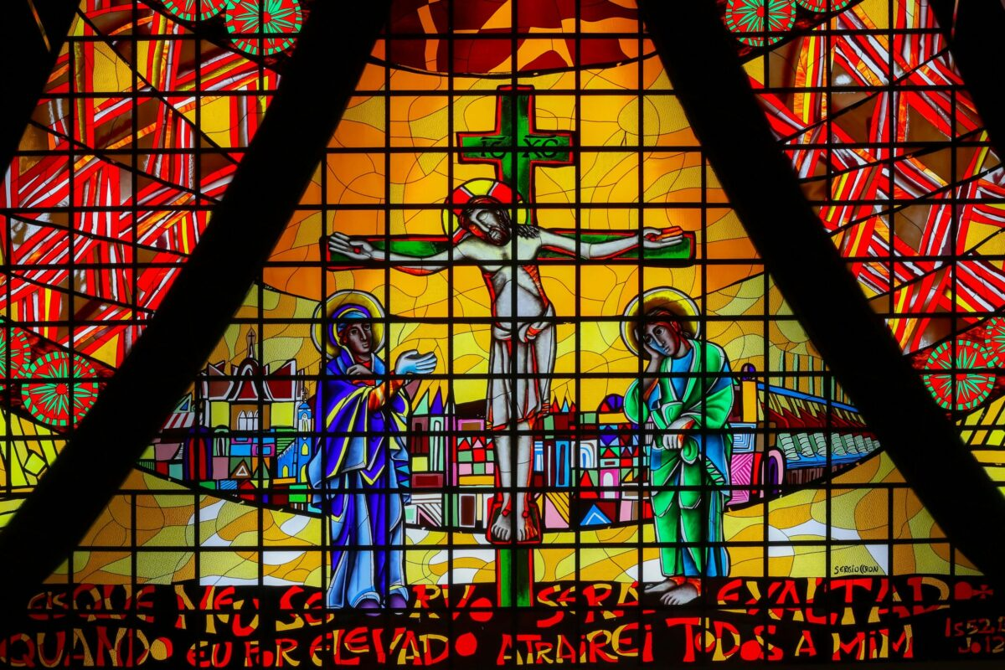

INTRODUCTION

Introduction

In August 2018, Pope Francis wrote:

“It is always helpful to remember that “in salvation history, the Lord saved one people. We are never completely ourselves unless we belong to a people. That is why no one is saved alone, as an isolated individual. Rather, God draws us to himself, taking into account the complex fabric of interpersonal relationships present in the human community. God wanted to enter into the life and history of a people” (Gaudete et Exsultate, 6).

Consequently, the only way that we have to respond to this evil (of abuse) that has darkened so many lives is to experience it as a task regarding all of us as the People of God. This awareness of being part of a people and a shared history will enable us to acknowledge our past sins and mistakes with a penitential openness that can allow us to be renewed from within. Without the active participation of all the Church’s members, everything being done to uproot the culture of abuse in our communities will not be successful in generating the necessary dynamics for sound and realistic change. The penitential dimension of fasting and prayer will help us as God’s People to come before the Lord and our wounded brothers and sisters as sinners imploring forgiveness and the grace of shame and conversion. In this way, we will come up with actions that can generate resources attuned to the Gospel. For “whenever we make the effort to return to the source and to recover the original freshness of the Gospel, new avenues arise, new paths of creativity open up, with different forms of expression, more eloquent signs and words with new meaning for today’s world” (Evangelii Gaudium, 11).

It is essential that we, as a Church, be able to acknowledge and condemn, with sorrow and shame, the atrocities perpetrated by consecrated persons, clerics, and all those entrusted with the mission of watching over and caring for those most vulnerable. Let us beg forgiveness for our own sins and the sins of others. An awareness of sin helps us to acknowledge the errors, the crimes and the wounds caused in the past and allows us, in the present, to be more open and committed along a journey of renewed conversion.

“No wonder so many people who have been abused find it so very difficult to forgive or to trust the Church anymore. They need to hear from Church leaders like me, that we realise the harm that has been done to them, that we are sorry for that, and that we want to make atonement. And I repeat that to them today. I am sorry for what happened to you. I am sorry for the terrible failures and crimes that happened in your Church, and I want to do my best to ensure that no one else suffers in the way that you did.” (ARCHBISHOP EAMON MARTIN FEBRUARY 2021)

One-off events place a temporary spotlight on child abuse which appears to dissipate. There is little inbuilt continuity and despite the best intentions, the next “one off event” bears little relation to the previous event. We need to compare this with the lifelong impact of childhood trauma that survivors experience. A proportionate response is required.

We cannot expect the impact of a once off event to endure forever for all survivors. In our ongoing ministry we must embed constant reminders about the abuse that occurred in our Church for ourselves, for those who have been abused, for the faithful and for children. We must continue to express our eternal sorrow with undertaking to do everything in our power to ensure it does not happen again (in line with the principles of restorative and transitional/conversional justice).

We must remind each other that the purpose of the event(s) is to ensure survivors know they are not forgotten and the Church continues to be sorry for all that happened them. We also take responsibility for the abuse so we can reassure them it was not their fault and by doing so we hope to assist them in their healing journey. At the same time, we are embarking on our own healing journey not as individuals, but as a people.

You are therefore invited to participate in the annual Day of Prayer for Victims and Survivors of Abuse in the Catholic Church in Ireland which is on Friday 20th February 2026 (the first Friday of Lent).

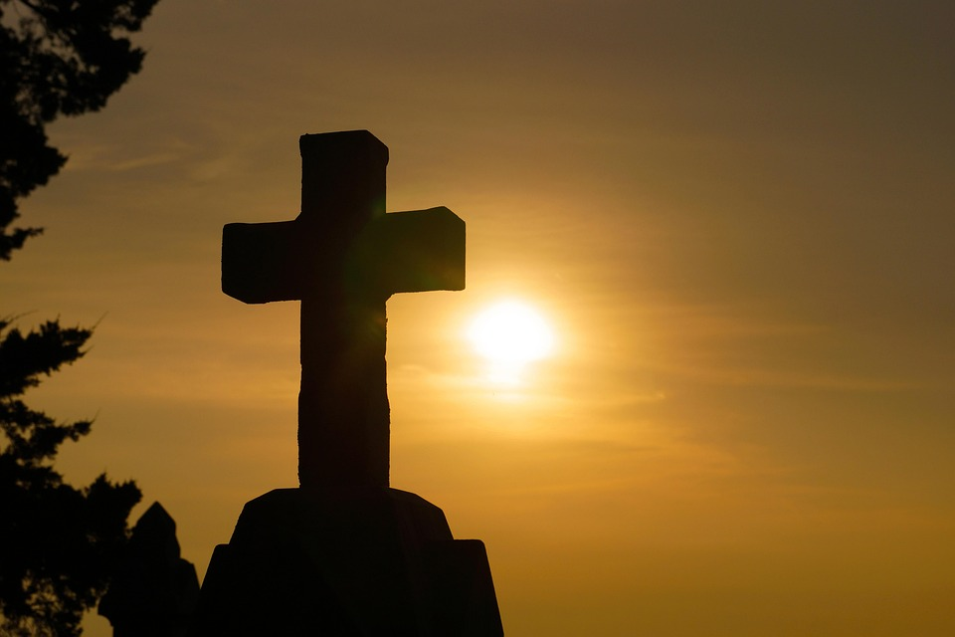PRAYERS

Prayers

Below are presented a selection of texts from Scripture, Reflections, Prayers, Litanies and Suggestions for Music that may be of help to you in preparing for the Day of Prayer and give you some ideas on how to express our solidarity with those who have suffered most.

The following prayer was sent to Archbishop Diarmuid Martin, Archbishop Emeritus of the Archdiocese of Dublin, by someone who suffered abuse so that it could be shared. It speaks with simplicity and sincerity:
Lord, we are so sorry
for what some of us did to your children:
treated them so cruelly,
especially in their hour of need.
We have left them with a lifelong suffering.
This was not your plan for them or us.
Please help us to help them.
Guide us, Lord, Amen.

Paidreacha dIdirghui
A Dhia, tá aiféal orainn
as ucht na rudaí a rinne cuid dúinn dod phaistí:
gur caitheadh leo chomh chrualach,
in am a gátar ach go háirithe.
Dfhágamar iad le cruatan saoil.
Níorbh é seo do scéim dóibh súid ná dúinne.
Cabhraigh linn le cabhair a thabhairt dóibh súid.
Treoraí sinn, a Thiarna, Amen.

A prayer for cleansing the temple of our soul
Do not let me find consolation in sensible devotion to the person of Jesus Christ,
While Jesus Christ passes me by
Unknown, unrecognised, unsought, uncomforted on the via crucis,
We travel together.
Do not let my heart be moved by pity for the painted Christ on the wall
While it remains stone
Hard, insensitive, to Christ suffering alone
In the ugliness of shame and disgrace, in the outcast, the shunned,
The Forgotten, in mental sufferers hidden away in hospitals,
In prisoners serving life sentences
In people wrestling with bitterness and despair
In those fighting a losing fight with human weakness and degradation –
In the unhealed, the uncomforted, the unloved… the abused
Do not give me tears to shed at the feet of the crucifix
While they blind me to Christ crucified
Unwept for in the soul of sinners and
In my own sinful soul (Carryl Houselander)

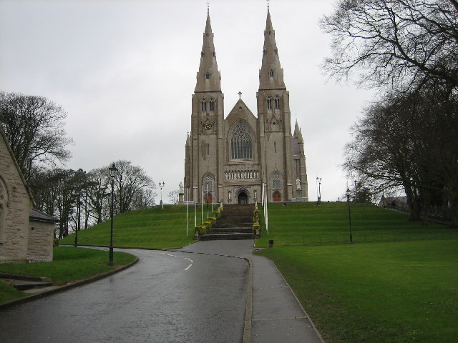
This Photo by Unknown Author is licensed under CC BY-SA

PRAYERS
of
INTERCESSION

Prayers of Intercession
[Include two or three of the following in your Prayer of the Faithful:]
Introduction: With humility of heart, let us pray to God,
whose love and faithfulness endures forever.

- We pray for all who have been abused
whether physically, mentally, emotionally or sexually:
that the Lord of all tenderness and compassion
will restore them and give them peace.

- We pray that we may become more and more
a community that actively cares for and protects
the most vulnerable sections of our society,
particularly our children.

- We pray for the Spirit of wisdom: that it will enlighten the minds of all
people and lead to a growth in awareness and a determination to put an end to
all acts of violence and abuse.

- We pray for all in the healing professions who minister to those who suffer
as a result of violence or abuse: that God will give them an abundance of love,
compassion and wisdom.

- Lord, we pray for the courageous survivors of abuse who remind us that healing and repair are not accomplished by the settling of accounts alone, but by restoring dignity and humility to all involved, in the presence of one another and before God.

- Lord, we pray for the strength of victims and survivors of abuse, who have the courage to own their woundedness even as we struggle to own the brokenness of the Church. Grant us the wisdom to learn from victims and survivors, so that we may help repair the wounds inflicted upon them. Guide us to jointly restore truth and integrity, while assisting victims and survivors to achieve reparation and justice.

Gui an Phobail
Le humhail croí, guímis do Dia, maireann a ghrá agus dilseacht go buan.

- Guimís ar son gach duine gur baineadh mí-usáid asta bíodh sin go fisiciúil,
go hintinneach, go maoithneach nó gréasach: go ndéanfadh an Tiarna atá lán de cineáltacht agus trua athneartú orthú an síocháin a thabhairt dóibh.

- Guimís go mbéimid ina phobal ata gríomhach ag tabhairt aire agus cosaint don
cuid dár sochaí atá gan chosaint, ár bpáistí ach go háirithe.

- Guimís ar son spiorad na crionnachta; go dtabharfar leargas dintinn gach
duine agus go dtreoraí se dfhás in eolas agus diongbháilteacht le deireadh a chuir le gníomhartha dfhoreigean agus mí-úsáid

- Guimís ar son na gairme cneasú a thugann fóirithint dóibh súid atá ag
fulaingt de thoradh ar fhoreigean nó mí-úsáid go dtabharfaidh Dia flúirse grá,
trua agus críonnacht dóibh.

- Dia ár gcarraig agus ár neart ar a gclaonaimid
cabhraigh linn atmaisféar de mhuinín a chruthú
ina gceadaitear an doluaite a lua.

- Cabhraigh linn maireachtan lenár gcuimhní pianmhar
Go dtugaimid tacaíocht dá chéile agus bheith mar áit slán da chéile.

- Guimis in ainm Íosa, do trua,
a mhaireann agus a rialaíonn trí shaol na saol. Amen.
Litany of Lament and Repentance
We turn to God in sorrow and humility, confessing our sins against God and God’s children, asking for mercy and forgiveness.

For the crimes and sins of sexual and physical abuse perpetrated by clergy and servants of the Church against children and young people; for the failure to love, respect, nurture and cherish young people – especially the most vulnerable. We ask your forgiveness.
All sing: Kyrie, Kyrie eleison (Plainchant)

For the immense psychological harm and lasting spiritual devastation caused to survivors abused by Church representatives. We pray for the healing and peace of those whose suffering continues at home and abroad.
All sing: Kyrie, Kyrie eleison

For the sins of bishops and religious superiors, when they failed to respond as good shepherds to survivors of abuse by priests and religious. For indifference in the face of human suffering, for putting the institutional Church before the safety of children, for covering up crimes of abuse, and by so doing actually causing the sexual abuse of more children. For their lack of compassion and pastoral love, for the scandal given to God’s people by their negligence and for the harm caused to the Church’s mission by those in authority and responsibility. We ask God’s forgiveness for the deaf ear, the blind eye and the hard heart.
All sing: Kyrie, Kyrie eleison

For the sins of those priests and religious who not only abused God’s children but also scandalised them in the way our Lord deplored. We pray also that they may find forgiveness and ultimate healing, be delivered from denial and sincerely repent.
All sing: Kyrie, Kyrie eleison

For any indifference and lack of compassion experienced by survivors of clerical and religious abuse by their fellow Church members, who could have supported them.
For any hostility towards them, refusal to believe them, lack of care and acceptance towards our brothers and sisters who were unjustly subjected to such pain.
All sing: Kyrie, Kyrie eleison

For the anguish and distress caused to the families and friends of those abused by priests and religious. We lament the burdens of sorrow they carry on account of the injuries inflicted on their loved ones.
All sing: Kyrie, Kyrie eleison

For those who died prematurely as a result of the spiritual, psychological, and emotional damage they suffered through abuse. We grieve for the wounds that did not heal in this world. We remember those who died as a result of suicide. May God be close to those who mourn their loss.
We remember them now, in a moment of silence…



REFLECTIONS

Reflection (Based on a prayer written by Brother Roger of Taizé)
Christ Jesus, Saviour of every life,
You take our burdens upon yourself.
You suffer with all who bear the cross of suffering
in whatever form it takes.
So that, with you, we can move forward:
from worry and anxiety to trust,
from darkness to light.
With you accompanying us,
even what pains our heart,
even our own darkness can be made bright
by the inner light of the Holy Spirit.
You stretched out your arms on the cross
and reconciled us to one another and to the Father.
You brought God and humanity together in your body.
Wrap your arms around our broken lives
and restore us to the harmony that exists in you.

REFLECTIONS and PRAYERS:
God of endless love,
ever caring, ever strong,
always present, always just:
You gave your only Son
to save us by the blood of his cross.

Gentle Jesus, shepherd of peace,
join to your own suffering
the pain of all who have been hurt
in body, mind, and spirit
by those who betrayed the trust placed in them.

Hear our cries of distress
over the harm done to our brothers and sisters.
Breathe wisdom into our prayers,
soothe restless hearts with hope,
steady shaken spirits with faith:
Show us the way to justice and wholeness,
enlightened by truth and enfolded in your mercy.

Holy Spirit, comforter of hearts,
heal your peoples wounds
and transform our brokenness.
Grant us courage and wisdom, humility and grace
so that we may act with justice
and find peace in you.
We ask this through Christ, our Lord. Amen.

(from a prayer produced by the US Conference of Bishops]

Praise to you, Father of our Lord Jesus Christ,
source of all consolation and hope.
By your Son’s dying and rising
He remains our light in every darkness,
our strength in every weakness.
Be the refuge and guardian
of all who suffer from abuse and violence.
Comfort them and send healing
for their wounds of body, soul and spirit.
Rescue them from bitterness and shame
and refresh them with your love.
Heal the brokenness in all victims of abuse
and revive the spirits of all who lament this sin.
Help us to follow Jesus
in drawing good from evil, life from death.
Make us one with you in your love for justice
as we deepen our respect
for the dignity of every human life.
Giver of peace, make us one in celebrating your praise,
both now and forever. Amen.
(Bishop of St Cloud, USA)

A Blessing: For Broken Trust
By John O’Donoghue
Sometimes there is an invisible raven
That will fly low to pierce the shell of trust
When it has been brought near to ground.
When he strikes, he breaks the faith of years
That had built quietly through the seasons
In the rhythm of tried and tested experience.
With one strike, the shelter is down
And the black yolk of truth turned false
Would poison the garden of memory.
Now the heart’s dream turns to requiem,
Offering itself a poultice of tears
To cleanse from loss what cannot be lost.
Through all the raw and awkward days,
Dignity will hold the heart to grace
Lest it squander its dream on a ghost.
Often torn ground is ideal for seed
That can root disappointment deep enough
To yield a harvest that cannot wither:
A deeper light to anoint the eyes,
Passion that opens wings in the heart,
A subtle radiance of countenance:
the soul is ready for its true other.

The Alexian Brothers’ Prayer to Christ the Healer
In the comfort of your love,
I pour out to you, my Saviour,
The memories that haunt me,
The anxieties that perplex me,
The fears that stifle me,
The sickness that prevails upon me,
And the frustration of all the pain
that weaves about within me.
Lord, help me to see your peace in my turmoil,
your compassion in my sorrow,
your forgiveness in my weakness,
And, your love in my need.
Touch me, O Lord,
with your healing power and strength.

A Prayer for Inner Peace & Transformation
Joyce Rupp

Dear God, come with me into this day. Be with me where the dark things are. Take my hand through the valley of shadows; cast out fear and pride from my heart. Allow me to see the great hollow spot in me that has never been transformed into you. Take me to the ‘Lazarus Gulf’; do not spare me from the terror of it. Only, please God, do not let go of me for I will fall into my fear and leave you.

Praise be to you, shining shield of love. Alleluia to you, great God of warmth whose strong hand in my own keep s taking me to places I’d rather not go. My trust is in you, divine companion. O maker of mine, O giver of my life, trudge with me down my path of death into the murky mud of my sin.
Stay with me as I see how unlike you I am, and then, beautiful gift of goodness, turn my heart around to face you. Allow me to behold the radiance of your astounding, wonderful beauty. Then, my loving God, I will be home.

The following reflections are based on prayers written by
Brother Roger of Taizé:
Christ Jesus, Saviour of every life,
You take our burdens upon yourself.
You suffer with all who bear the cross of suffering
in whatever form it takes.
So that, with you,
we can move forward:
from worry and anxiety to trust,
from darkness to light.
With you accompanying us,
even what pains our heart,
even our own darkness
can be made bright
by the inner light of the Holy Spirit.
You stretched out your arms on the cross
and reconciled us to one another
and to the Father.
You brought God and humanity together in your body.
Wrap your arms around our broken lives
and restore us to the harmony
that exists in you.

*****
Jesus our hope, Peace of our hearts,
in you we find the consolation
God wants to pour into our lives.
And we understand that, in prayer,
we can bring everything to you
entrust everything to you:
even the things of which we are ashamed
even the things of which we are afraid.
Help us to live each day as a day that belongs to you,
and to rejoice at what you accomplish in our souls.
In this way we can be channels of your peace,
living vessels of your presence.
Jesus, help us to live by the words you speak to us:
“My peace I leave you
Do not let your heart be troubled anymore.”

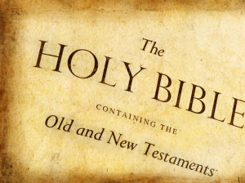
This Photo by Unknown Author is licensed under CC BY-NC-ND
READINGS

From the letter of St Paul to the Romans 8:26-27
When faced with great difficulty, we often can be at a total loss for words.
But the Spirit of God can express even our sighs to the heart of God.
The Spirit comes to help us in our weakness.
For when we cannot choose words in order to pray properly,
the Spirit himself expresses our plea
in a way that could never be put into words,
and God who knows everything in our hearts
knows perfectly well what he means,
and that the pleas of the saints expressed by the Spirit
are according to the mind of God.

From the first letter of St Peter 5: 5b, 7, 10b-11.
Wrap yourselves in humility to be servants of each other,
because God refuses the proud and will always favour the humble.
Unload all your worries onto Him,
since He is looking after you…
The God of all grace
who called you to eternal glory in Christ
will see that all is well again:
he will confirm, strengthen and support you.
His power lasts forever and ever. Amen.


This Photo by Unknown Author is licensed under CC BY-SA
RESPONSORIAL PSALMS

From Psalm 33
The Lord is close to the broken hearted
I will bless the Lord at all times,
His praise always on my lips;
in the Lord my soul shall make its boast.
The humble will hear and be glad.
The Lord is close to the broken hearted

Glorify the Lord with me.
Together let us praise His name.
I sought the Lord and He answered me;
from all my terrors He set me free.
The Lord is close to the broken hearted
Look towards Him and be radiant;
let your faces not be abashed.
When the poor cry out the Lord hears them
and rescues them from all their distress.
The Lord is close to the broken hearted

The Lord is close to the broken hearted;
Those whose spirit is crushed He will save.
The Lord is close to the broken hearted

From Psalm 68 (69):
In your great love, answer me O God
I am wearied with all my crying,
my throat is parched.
My eyes are wasted away
from looking for my God.
In your great love, answer me O God

This is my prayer to you,
my prayer for your favour.
In your great love answer me O God,
with your help that never fails.
In your great love, answer me O God
Lord, answer, for your love is kind;
in your compassion, turn towards me.
Do not hide your face from your servant;
answer me quickly for I am in distress.
In your great love, answer me O God

As for me in my poverty and pain,
let your help, O God, lift me up.
In your great love, answer me O God

From Psalm 26
The Lord is my light and my help
The Lord is my light and my help;
whom shall I fear?
The Lord is the stronghold of my life;
before whom shall I shrink?
The Lord is my light and my help

For there He keeps me safe in his tent
in the day of evil.
He hides me in the shelter of his tent,
on a rock he sets me safe.
The Lord is my light and my help

O Lord, hear my voice when I call;
have mercy and answer.
Of you my heart has spoken:
“Seek His face.”
The Lord is my light and my help
It is your face O Lord that I seek;
hide not your face.
Dismiss not your servant in anger;
You have been my help.
The Lord is my light and my help
Do not abandon or forsake me,
O God my help!
Though father and mother forsake me,
the Lord will receive me.
The Lord is my light and my help

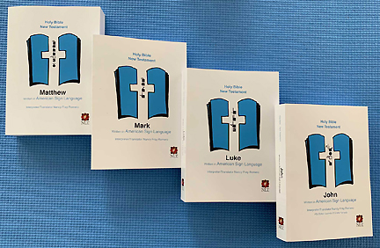
This Photo by Unknown Author is licensed under CC BY-SA
GOSPEL TEXTS

From the Gospel according to Matthew 11:28-30
Jesus said to His disciples:
“Come to me, all you who labour and are overburdened,
and I will give you rest.
Shoulder my yoke and learn from me,
for I am gentle and humble in heart,
and you will find rest for your souls.
Yes, my yoke is easy and my burden light.

From the Gospel according to Matthew 18:5-7a, 10
Jesus said to His disciples:
“Anyone who welcomes a little child in my name welcomes me.
But anyone who is an obstacle
to bring down one of these little ones who have faith in me
would be better drowned in the depths of the sea
with a great millstone round his neck.
Alas for the world that there should be such obstacles!
See that you never despise any of these little ones,
for I tell you that their angels in heaven
are continually in the presence of my Father in heaven.”

From the Gospel according to Mark 4:35-41
With the coming of evening, Jesus said to his disciples, Let us cross over to the other side. And leaving the crowd behind they took him, just as he was, in the boat; and there were other boats with him. Then it began to blow a gale and the waves were breaking into the boat so that it was almost swamped. But he was in the stern, his head on the cushion, asleep. They woke him and said to him, Master, do you not care? We are going down! And he woke up and rebuked the wind and said to the sea, Quiet now! Be calm! And the wind dropped, and all was calm again

From the Gospel according to John 10:11-18
Jesus said:
“I am the good shepherd:
the good shepherd is one who lays down his life for his sheep.
The hired man, since he is not the shepherd
and the sheep do not belong to him,
abandons the sheep and runs away
as soon as he sees a wolf coming,
and then the wolf attacks and scatters the sheep;
this is because he is only a hired man
and has no concern for the sheep.
I am the good shepherd;
I know my own and my own know me,
just as the Father knows me
and I know the Father;
and I lay down my life for my sheep.”
Jesus Arrested (Luke 22:47-52)

While he was still speaking a crowd came up, and the man who was called Judas, one of the Twelve, was leading them. He approached Jesus to kiss him, but Jesus asked him, “Judas, are you betraying the Son of Man with a kiss?”

When Jesus’ followers saw what was going to happen, they said, “Lord, should we strike with our swords?” And one of them struck the servant of the high priest, cutting off his right ear.
But Jesus answered, “No more of this!” And he touched the man’s ear and healed him.
Then Jesus said to the chief priests, the officers of the temple guard, and the elders, who had come for him, “Am I leading a rebellion, that you have come with swords and clubs? Every day I was with you in the temple courts, and you did not lay a hand on me. But this is your hour—when darkness reigns.”
Andrew Graystone, writer, theologian, and advocate for victims and survivors of church abuse, recounts that “in the middle of chaos and threat, Jesus made it his absolute priority to heal the person his disciple had hurt.”

From the Gospel according to John 14: 1
Jesus said to His disciples:
“Do not let your hearts be troubled .
Trust in God still,
and trust in me.”

From the Gospel according to John 14: 27
Jesus said to His disciples:
“Peace I bequeath to you,
My own peace I give you,
a peace the world cannot give, this is my gift to you.
Do not let your hearts be troubled or afraid.”

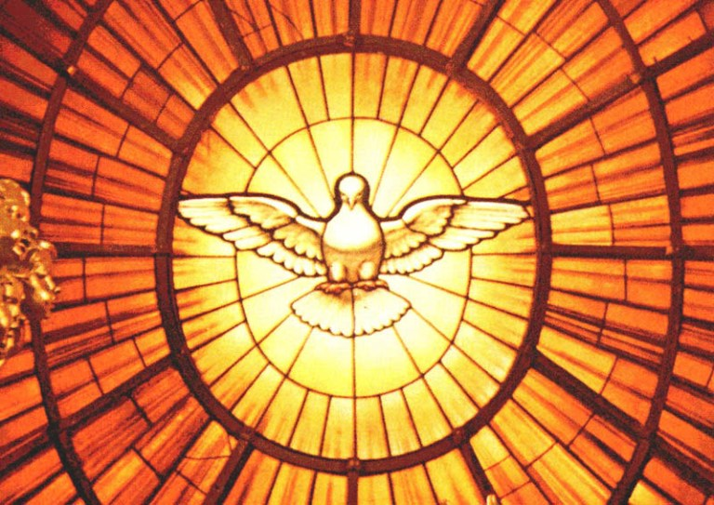
This Photo by Unknown Author is licensed under CC BY-NC-ND
LITANIES

LITANIES
In the Gospel of Matthew, even before Jesus is born he is also called:
“Immanuel – a name which means ‘God-is-with-us’” [Matt 1:23]
Jesus’ first work is to accompany us.
We hear it again the invitation to Jesus
from the two disciples on the Road to Emmaus:
when “they pressed Him to stay with them” [Luke 24:29]

We invite Him to accompany us as we pray:
(Our response is: ‘Stay with us Lord’)
When peace is fragile Stay with us, Lord
When tempers are raised Stay with us, Lord
When atrocities occur Stay with us, Lord
When forgiveness is rejected Stay with us, Lord
When talks break down Stay with us, Lord
When agreements are broken Stay with us, Lord
When darkness weighs upon us Stay with us, Lord
When we cannot see you Stay with us, Lord
When burdens feel too heavy Stay with us, Lord
When hope seems faint Stay with us, Lord
When we are weak Stay with us, Lord
When faith seems difficult Stay with us, Lord

We ask the Risen Lord to continue to walk with and protect those who are burdened –
(our response is: Walk with them, Lord)
For all who have lost hope Walk with them, Lord
For all who suffer Walk with them, Lord
For all who are sick and in pain Walk with them, Lord
For all who are struggling Walk with them, Lord
For all who have been badly hurt in life Walk with them, Lord
For all who are grieving Walk with them, Lord
For all who are depressed Walk with them, Lord
For all who feel rejected Walk with them, Lord
For all who feel unloved Walk with them, Lord
For all who are oppressed Walk with them, Lord
For all who are anxious Walk with them, Lord

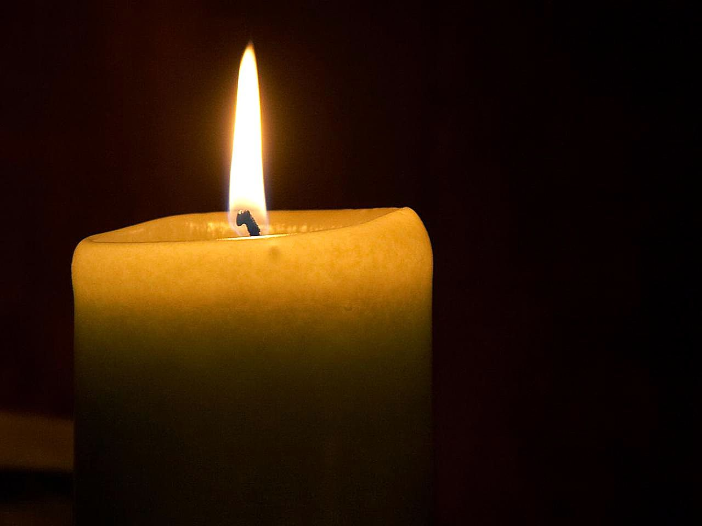SYMBOL oF
LIGHT & HOPE

Symbol of Light and Hope – Candle of Protection

Jesus is the light of Ireland and the world. We pray that blessing will flow from this terrible wound and we trust that God will bring blessing from all the pain that has been endured by the abused children. Where sin abounded we trust that the grace of God will all the more abound. We hope that our act of repentance may open all our hearts to receiving the unconditional love of God as expressed in Jesus, His Son.
We are determined that Evil will not have the last word but that out of the suffering of the many abused children will grow a new compassion that will be truly reflective of Jesus’ love and care for the young.
A light is taken from the Paschal candle to the Candle of Protection
Prayer of Blessing:
Lord we ask you to bless + this candle, a simple sign of our hope for the future and for the healing of lost innocence. May this candle be symbol of renewal for all who worship here at the Pro-Cathedral. May we pledge ourselves to the cause of protecting young people as Mary and Joseph guarded their precious child.
Song Christ be our light (Bernadette Farrell)

Candle of Atonement

“The Candles are a reminder to pray for all those who carry lifelong suffering following abuse – they symbolise repentance, light in the darkness and hope.”- Archbishop Eamon Martin

During their retreat in Knock in 2018, the bishops of Ireland blessed and dedicated candles of atonement for use in their Cathedrals and parishes throughout the country on 15 February 2019 and thereafter during the celebration of Mass and other liturgies.

Speaking in 2019 Archbishop Eamon Martin said, “I welcome the candles of atonement initiative, and the accompanying prayer which was written by a survivor of abuse. In lighting these candles we will bring to mind our brothers and sisters, and their families, who have been left with a lifelong suffering as a result of abuse, whose trust was so deeply betrayed and whose faith has been so cruelly tested within the sanctity of the Church by perpetrators of abuse.

“In recent weeks I have been privileged to meet with victims and survivors of abuse and members of their families in the four provinces of Ireland. Many have spoken to me about the importance of prayer for survivors, and for the need for the Church to be open to justice, to atone and never forget them. I have been humbled by their courage and overwhelmed by their generosity of spirit. It is my intention to relay the lived experience and insights of Irish survivors, both personally to Pope Francis, and more widely to the safeguarding meeting in Rome later this month.

“I encourage dioceses and parishes to undertake this new prayer initiative and to light the ‘Candle of Atonement’ in Cathedrals and churches across Ireland. It would mean a lot to survivors if the ‘Candle of Atonement’ was a permanent feature in our Cathedrals and parish churches.

People visiting the church for quiet prayer might light the ‘Candle of Atonement’, pray the prayer, and bring to mind someone they know who has been directly impacted or affected by abuse…..I am convinced that prayer and outreach to survivors of abuse is a modern-day corporal and spiritual work of mercy.”

“The ‘Candle of Atonement’ and accompanying prayer are offered as a reminder to all of the need for us to atone, to ask forgiveness as a Church for the suffering caused by abuse. My hope is that these candles will be lit in Cathedrals and parishes across the country as a reminder of the need for atonement and that they will symbolise repentance, light in the darkness and hope.”

Candle of Atonement Prayer
Lord, forgive us our many sins.
We grieve and repent with all our hearts for having offended you, for our great failings and neglect of the young and vulnerable.
We place all of those who have been hurt by the Church in any way into your loving hands and under the protection of Our Blessed Mother.
Lord, bring peace to their broken lives and show us all the way out of darkness and into the light of your Word.
May we as the people of God be more fully human, more fully Christ-like and more fully your people, that we may see the errors of the past and go forward with renewed hope and faith in Christ and in our Church.
Amen


Concluding PrayerS

God our rock and our strength on whom we lean,
help us to create an atmosphere of trust
which allows the unspeakable to be said.
Help us to live with our painful memories.
May we support each other and be safe places for each other.
We pray this in the name of Jesus, your compassion made flesh,
who lives and reigns with you for ever and ever. Amen.

To those who love you, Lord, and who take refuge under your wings, you promise in the Psalm: ‘They shall call upon me, and I will answer them; I will be with them in their distress.’ We pray to you: fulfil your promise. Here we are in distress; stand by our side. Come with your tender love and gentle healing to all who suffered any form of abuse when they were young. Especially comfort those who were abused by priests and religious. Shelter them, protect them, heal them and enfold them in your infinite love. To you we cry out for pardon and forgiveness. Purify your church of all scandal and corruption through the refining fire of the Holy Spirit. Save us and have mercy on us, through Jesus Christ, our redeemer and our brother. Amen.


MUSIC
&
HYMNS
Stand beside me John Columba McCann OSB
Healer of my soul John Michael Talbot
The Lord will heal the broken heart (God of life) Liam Lawton
The Cloud’s Veil Liam Lawton
Heal us, Lord Liam Lawton
Christ be near at either hand Traditional
A Mhuire Mháthair Tradisiúnta arr. Ian Callanan
Sé an Tiarna m’Aoire Fintan O’Carroll
Calm me Lord Margaret Rizza
Your Mercy Like Rain Rory Cooney
Be still and know that I am God anon.
Be still my soul K. von Schlegel/Sibelius
My soul is longing for your peace Lucien Deiss
Within our darkest night Taizé
Lord Jesus Christ, your light shines within us Taizé
Keep me safe O God John Foley

