Books edited by Marcia J. Bunge on
Biblical and Christian Understandings of Children and Childhood
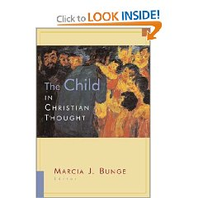
https://www.amazon.com/Christian-Thought-Religion-Marriage-Family/dp/0802846939/ref=sr_1_3?dchild=1&keywords=Child+in+Christian+thought&qid=1629112471&sr=8-3
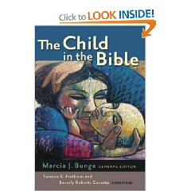
https://www.amazon.com/Child-Bible-Marcia-J-Bunge/dp/0802848354/ref=pd_bxgy_img_1/130-5225159-8572604?pd_rd_w=3dwBI&pf_rd_p=c64372fa-c41c-422e-990d-9e034f73989b&pf_rd_r=250T2XQNE0XHBK4QSRS1&pd_rd_r=3f73185a-6678-410b-b223-d96c2a2d8f2d&pd_rd_wg=mLqmO&pd_rd_i=0802848354&psc=1
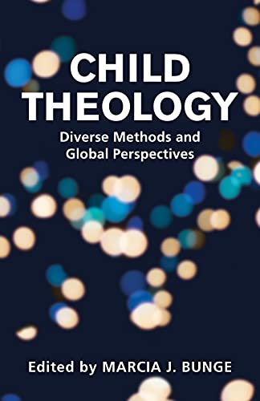
https://www.amazon.com/dp/B097Q5FX8Q/ref=dp-kindle-redirect?_encoding=UTF8&btkr=1

